**Domain Model: Class Diagrams**

AnteaterGroups

**Domain Model**

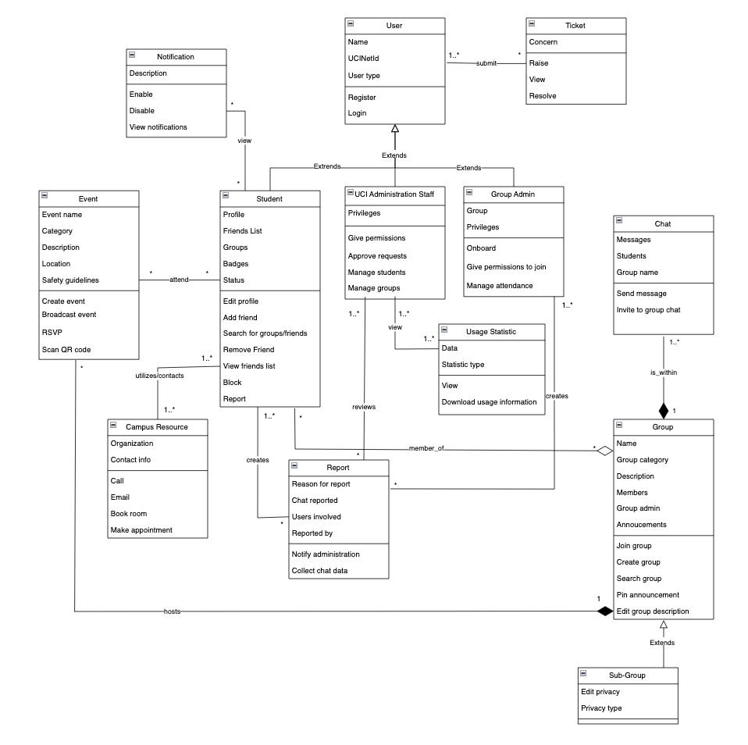

# **Class Descriptions**

**User**

Users of the AnteaterGroups include UCI students, UCI administration staff, and AnteaterGroups group administrators. Operations which users can perform are register and log in. Users must register and log in to the software using their UCInetID to verify their affiliation with UCI. Upon registration, a user is categorized into one (or more) of the following categories: student, UCI administration staff, and group administrator. When a user gains another role, this shall be reflected on their profile as a badge which is visible to all other users. All users are required to use their full name as their representative/display name as registered with the UCI directory. Users are able to perform tasks such as joining and managing groups, chatting with users one-on-one, and viewing events.

Source: Field notes 16, 26, 37, 57, and 58, “Registration” goal

**Student**

A student is a person attending UCI and is enrolled in an undergraduate or graduate program. Students’ attributes include a profile, friends list, groups list, badges, and status. Operations that students can perform are: edit profile, add friend, remove friend, view friend list, search for groups/names, block, and report. Students are part of the parent *User* class, which means they inherit the attributes and operations of that found in the User class.

Source: “Improve students’ social connectedness” goal model, “Improve student involvement with campus resources and organizations” goal model

**UCI Administration**

A UCI administrator is someone who manages the students’ accounts, groups, and any activities on the AnteaterGroups app. UCI admin staff has the privileges to give certain permissions to accounts on the app, approve requests from students and groups, manage students and groups and their activities, and get usage statistics data.

Source: Case study, Field Notes 38, 50, “Manage group app activity” goal

**Group Administrators**

A group administrator is a user who has unique managerial privileges for the group they are an admin of. A user becomes a group admin by being onboarded into their position. They can also give permissions to join groups and are the ones to manage group event attendance. Group administrators shall generate QR codes, promote activities, and change their group settings (public or private) at any time. Group administrators who are also graduating students shall be replaced with another student administrator.

Source: Field notes 5, 6, 8, 39, 75, 77, “Access to groups” goal

**Ticket**

A ticket is an issue or concern a User has with AnteaterGroups. Tickets’ attributes include a reason for writing a ticket (the concern). Tickets can be submitted, raised, viewed, or resolved, and are accepted and handled by UCI OIT (UCI Administration).

Source: Field notes 92

**Report**

A report is performed by the group admin and students to alert misbehaving accounts on the app. Reports will be sent to UCI Administration Staff for further review and appropriate action to violated accounts; this can mean a ban on the account or a restriction for certain features on the app. More serious violations are reportable to UCI Police Department or UCI Administration for appropriate penalty for the specific student. Reports are anonymous.

Source: Field notes 12, 25, 52, 69, 72, ReportBehavior use case, “Report Inappropriate Behavior” goal

**Chat**

A chat feature will be available within groups for students to interact with one another, and group admin can participate in chat with other students as well. An algorithm will be used to scan for inappropriate messages and language in the chat for report purposes. Students can have private chat sessions with people that are on their friends list. Group admin does not have full access to chat history, and reports will be sent to group admin for further reviews and escalations.

Source: Field notes 25, 29, 33, 36, 53, 92, 93, goal model “Improve students’ social connectedness”, use case “ChatWithOthers”

**Notification**

A notification is a short description of information that the user needs to view. This could be information about friend suggestions, maintenance updates, group related events, and more. Notifications have a description and can be enabled, disabled, and viewed.

Source: Field notes 18, 41, 68, 85

**Usage Statistic**

A usage statistic provides information about the application’s use, such as headcount for a group, number of students registered, and other relevant information. Usage statistics will have data and a statistic type. UCI Administration will be able view this data and also have the ability to download this information.

Source: Field notes 38, 50, use case “ViewUsageMetrics”

**Campus Resource**

A campus resource is an organization at UCI that can be utilized by students. Students are able to call the UCI Health Safety Escorts, book a UCI Library study room, and make an appointment to meet with a UCI Wellness mental health specialist. Students can also email these organizations as their contact information is provided.

Source: UtilizeCampusResources use case, “Improve student involvement with campus resources and organizations” goal model

**Group**

Groups are made up of students who are interested in the group, and these students can chat amongst themselves within the group. Groups have a group name, a category they can be generalized under, a description that can be edited, list of members, and an admin. Groups can be joined, created, and searched for. The announcements of the group can be pinned by the group. Groups are public unless they are a sub-group, and main groups host events.

Source: Case Study, JoinGroup use case, CreateGroup use case, SearchGroup use case, Field Notes 80, “AccessToGroups” goal

**Event**

An event is a planned activity hosted by one of the groups. These events serve to encourage students to connect with each other and participate more. Events hold information about their name, category, description, location, and safety guidelines. Events can be created, broadcasted, RSVP’d, and scanned with QR codes.

Source: Field notes 5, 6, 82, 90, goal model “Enhance Students’ Interests”

**Sub-Group**

Sub-group extends the Group class and inherits its attributes. Sub-groups can be created so that 2 or more students can chat with each other without chatting with the entire group. Sub-group names are visible to all group members but accessing them requires either admin approval or a password if they are marked as private.

Source: Field notes 39, 49, 63, 93

# Missing Information

Assumptions:

* A user has a badge on their profile which indicates their status as one of the following: student, UCI administration staff, and group administrator; this is visible to all other users.
* Tickets are handled by UCI OIT.

Questions:

* Will users be able to see user types (student, staff, group admin)?
* Do users have to manually choose their type, or will this be done by the system during registration?
* Will changes to a user’s type be reflected instantly?
* Will student workers be able to have the staff role as well, and will they be able to separate their student and staff profiles (ex. intern/office worker for UCI CARE)?
* Do UCI administrators notify students who have submitted reports about the status of their report?

# Team Meeting Minutes

| **Team ID: 3** | | **Date: 05.18.2022** |  | |
| --- | --- | --- | --- | --- |
| **Team Members (Name)** | | **Role** | |
| 1. Gail Manlapaz | | Facilitator | |
| 1. Michael Nguyen | | Participant | |
| 1. Jaime Park | | Recorder | |
| 1. Nathan Van | | Participant | |
|  | |  | |
|  | |  | |
| **Agenda for this meeting, List of agenda items** | | **Outcomes** | |
| 1. Work on class diagram | | We completed the class diagram in about 3 hours. | |
| 1. Complete class descriptions | | We worked on class descriptions from 4pm to midnight at different times depending on our individual availability. | |
| 1. Assemble homework 5 document | | We completed homework 5. | |
|  | |  | |
|  | |  | |
| **Problems encountered** | | **Resolution** | |
| 1. We were confused about which operations to put under each class. It seemed that some operations could fall under two different classes depending on how they’re looked at. | We had to move operations around, for example with a Group Admin managing attendance, we could have put this under the event because the attendance is for the event but we believed that it was more important to consider that the Group Admin would be the one managing the attendance. | | |
| 1. We found out that we did not have enough information from our elicitation sessions that clarified certain behaviors of a class. | We had to come up with appropriate assumptions that we would be clarifying with the customer in the next elicitation session. | | |
| 1. When determining multiplicity, it was difficult to determine whether a class relationship was zero or more or one or more. | We had to consider that some classes are not required for the system to function, for example there can be zero reports made. | | |
| 1. When brainstorming the classes we would be making, we discovered that we were making classes that were too specific that could have fit into an already existing class. For example, a profile class, but the operations of a profile could all be done by a student and a student has a profile as an attribute already. | We had to remove these classes that we found to be redundant in our overall class diagram and integrate them into existing classes. | | |
| ….etc. | |  | |
|  | |  | |
| **Plans for next meeting: Activity** | | **Responsibility** | |
| 1. Continue the elicitation session on Friday and ask the questions that we have made assumptions with from homework 5. | | All members. | |
|  | |  | |
|  | |  | |
|  | |  | |
|  | |  | |

# 

# **Field Notes**

## **(Week 2) - 4/12**

1. 10-12 fixed groups (no strict number)
2. Ask interest /hobbies/likes upon registration
3. Customization on front page of students interest/hobbies/etc
4. Can you search for groups by some tags or by a group name?
   1. Yes, make it as user friendly as possible
   2. When the student logs in, would be good to search for a group using name or tag
      1. Names and subjects
      2. Should match keyword even if it isn’t exact (near match)
      3. Tags: category (sports), group names: specific (football, baseball etc)
5. Should students be able to promote their own groups/events?
   1. Admin is allowed to promote group or events
   2. Students can be admins of groups they create and promote group activities
   3. Afraid of giving advertisement privilege to each and every student joining in, might be a lot of noise / not a lot of precise advertisements
6. Who are allowed to create groups/events? Who gives admin level account status to students? How to manage duplicate groups/events?
   1. Student leaders need verification with the admin of the app to get permission to create groups/events.
   2. Admin accounts can set groups/events as public (everyone can join) or private (request to join).
7. What are the ways to offer and award incentives to students? Do students get digital goods, physical goods, or reward points to be redeemed through the app or through a third-party partner?
   1. Students can participate in events and get reward points which can then be used to purchase digital goods and digital gifts.
   2. Digital goods and gifts can be sent from student to student.
8. Students who manage roles (ex. ARC: gym, swimming pool) can be onboarded as admins by default
   1. Campus admin would pick a student to be an admin of each group
9. How would rewards be distributed?
   1. Reward based on attendance
      1. Example: yoga meditation, simple reward system, if the student has more than 50% attendance, he/she gets some reward which can be given by the person conducting yoga sessions
   2. Need some system (db) to track attendance
   3. Gold/silver badges based on attendance and will be visible on ‘About Me’ section in profile
10. Multiple groups for the same subject?
    1. Students have the ability to create private groups within bigger group
11. Where can students form groups? On-campus only or any locations off-campus is fine too? Can they form groups at private locations?
    1. Due to the safety and security of the students.
    2. Campus Safety Council, Public Safety, Police Department
12. Who will get reports on users’ interactions and violations?
    1. To allow abusive/inappropriate behavior be reported to the student safety council and the police if necessary. To avoid student bullies and promote professionalism.
13. Organizations and clubs that have already been established - will they be able to create groups so they can recruit students?
    1. Yes (?) board all orgs on the app
14. If we see a class that is taught by 2 diff professors, students might want to have a group specified for each professor
    1. Repeating groups is fine with overlapping classes/different professors (making 2 groups)
    2. People like to shadow groups, doesn’t have to be restrictive, let people mix up/sign up for any groups they want
15. Potential launch date: September 2022
16. Should support at least 10k users (note: 30k students if all students participated)
    1. Should keep in mind scalability
17. Messages in specific channels can be seen by everyone regardless of their group (advertisement channel?)
18. Can send push notifications to everyone for important announcements
    1. Settings: allow user to enable or disable this
19. **Note: no alumni access allowed**
20. Groups centered around classes and sections - do these groups expire at the end of the quarter (to discourage collaboration)?:
    1. We don’t really need to onboard the classes as groups in our app
    2. App is used to promote connectivity, already have canvas for classes, redundant
21. Don’t include academic classes (what you see on webreg or canvas)
    1. Academic clubs are fine
22. How do we gather data on students’ interest to suggest groups?
    1. Competitor app: MeetUp (borrow registration process)
23. Can there be groups for certain majors or schools but not specific courses?
    1. Yes
24. Both android and apple compatible
25. Will the admin check for academic dishonesty or will students have privacy within their groups?
    1. Detect inappropriate/abusive chat with machine learning algorithm, proceed with warning then block student from using application if behavior continues 2 or 3 more times
    2. Students will also have the ability to report other students if there is inappropriate behavior and admin will be able to review report and take action
26. What other features besides creating and promoting connectedness and personal growth should the app have? Do students have the option to seek a mental health hotline or reach a specialist to address their mental health issues through the app?
    1. To further address and enhance social healthiness among the students.
    2. UCI Administration, UCI Student Affairs, UCI Center for Student Wellness & Health Promotion, Software Engineers.
27. Should students see friend suggestions as well as group suggestions? (like if you have a mutual friend w/ someone, will they be suggested to you?)
    1. yes
28. Features to police the app activity for inappropriate behavior
    1. Yes, try to detect inappropriate/abusive behavior using tech first (engineering challenge)
29. When a student reports another student, does the admin come in and view the activity in the chats? Or is there any expectation of privacy, or encryption? Does the administration have full access to all communications?
    1. Don’t give admin full access to chats
    2. Reporting will go to admins along with previous 4-5 chats where the user flagged as inappropriate
30. Should applications support e2e?
    1. Yes, to ensure privacy among students and app data
31. What happens when the lead admin graduates? Will the group be deleted or expired, or will someone take over the admin role?
    1. We don’t want the group to be deleted, would also like to pass on admin access to another student
32. Will the admin role be randomly assigned?
    1. Anything is fine as long as there’s an admin in the group
33. Can we always have a private chat feature?
    1. Yes, once someone in the group is your friend you can privately message them
34. Can students access anteater groups through a website or is the website for admins only?
    1. Just the app for now
35. Where can students form groups? On-campus only or any locations off-campus is fine too? Can they form groups at private locations?
    * 1. Due to the safety and security of the students.
      2. Campus Safety Council, Public Safety, Police Department.

## 

## **(Week 3) - 4/15**

1. Priorities
   1. Prototype: should have bare minimum of login, can see groups on home screen, can customize it for each student depending on hobbies, functioning chat system,
2. Will students be able to use aliases for their profiles or should they use real names?
   1. Real name
   2. Provide as much flexibility as possible
3. Campus admin can see usage statistics - what other metrics should admin be able to view?
   1. How many students logging in/registering, centralized dashboard of how many students have created groups, single page,
   2. Consistency ?
   3. Data about performance, if groups are/aren’t performing well
      1. Can reach out to group admins to ask them how to make it more engaging
   4. Only public group data ?
4. Can students create groups on their own or do they need to reach out to administrators?
   1. Give them the freedom to make their own groups
   2. Ability to create private groups (can toggle/change at any time - maybe only group admin can change?)
   3. Private groups invisible to public
   4. Students have the option to create public/private groups (can change after creation)
   5. Let’s not have private/public groups but ‘subgroups’ where they are all visible to students but some subgroups have password secure or approval permissions by the admin.**
5. Percentage of up time for application?
   1. Available 24/7
   2. What time should maintenance be performed? (discussion among engineers)
      1. Find time where app is used the least and perform maintenance time during that
6. Will students get notifications or reminders for maintenance?
   1. Once in two months or whenever there is a major break/crit issue
7. What kind of rewards should students receive for participating in group activities/events?
   1. Badges (bronze, silver, gold, etc, titles)
      1. Visible publicly
      2. For other students to see and connect with each other
      3. To get an idea of the student profile
   2. Points
8. How easy is it to integrate the library API?
   1. Libraries as stakeholders
   2. Would require looking at the code
9. What info do students need to complete their profile?
   1. Name
   2. Profile pictures
   3. Short description (optional)
   4. mail id or phone number (optional)
   5. Media upload/ social media links (optional)
10. How to encourage students to explore new interests?
    1. Initial data with their interests from registration on home page, option to see all groups or top 10-15 interests/groups, option to search for groups
11. Tags for age requirements (ex. 21+)
    1. Need to show id
12. Should the app integrate with a third-party map for locating events?
    1. third -party map integration
13. Creating duplicate groups
    * 1. If student creates a subgroup that is similar to existing, ask them if they want to
    1. still create or not
14. Friends list
    1. Close friend sublist
    2. Can create subgroup

## 

## **(Week 4) - 4/22**

1. Data visualization
   1. Admin will be able to see metrics (app usage, headcount in each group)/data on a single page.
   2. Admin can take measures if the headcount in a group is going down; promote more activities in a group.
2. Timeline
   1. Mock up: 1 month + 1 week
   2. Final product: Targeting release for the next AY Fall 2022 (September 2022).
   3. Have the application ready by orientation so that the department can market or promote app awareness. (MVP)
3. In case of inappropriate behavior, can users contact the police through the app?
   1. Workflow: users report, admins review report, then admin can contact police if needed.
   2. Possible late night concerts: have the features to take the shuttles back home.
   3. Make use of existing UCI services.
   4. Show the phone numbers ^^ on the app
4. Will there be ways to video chat with the mental health specialist?
   1. Students can schedule sessions over Zoom or Google Meet through the app
5. Will there be any accessible options/features for people with disabilities?
   1. Yes, w/ colors and fonts (will require research on what these students need)
6. Dark Mode Feature
7. What would other accounts (professor) be able to view on the application?
   1. Let the view be the same, but have some of the privileges of admins.
   2. Unique features only available to admin accounts
      1. Ex. the right to remove a student from a group
8. Will grad students have different privileges compared to undergrad students?
   1. Let them have the same privileges
9. Are faculty members allowed to join, and if so, can students connect with them like they do with their peers?
   1. no , trying to promote connectivity of students
   2. If they’re trying to train people (ex. Yoga group) they’re allowed to join(onboarded) but can’t use it like an end user
   3. Unlikely be end users
   4. Can be admins
10. Almost everyone associated with UCI has netID so we need to check the database for student status before every login.
11. What is the budget range that will be allocated for this application?
    1. I think he answered this - depends on skills of engineer and other stuff
12. How to reserve locations to meet
    1. library/study centers have their own system so we use that
    2. For non reservable places: let’s not bother because everyone one has access to aldrich park for example
    3. Have a popup reminder or show somewhere on the app that certain locations are under maintenance or are closed

## 

## **(Week 5) - 4/29**

1. What happens when a group gets too big or has been established for a long time?
   1. “Official Group of UCI”
2. Can anyone create groups or do students have to create subgroups of groups?
   1. Students can have both
   2. Already a group for things like music (100 students registered automatically)
   3. Friends list
   4. You can create a mini group/subgroup
3. Want to have pre-established groups and also groups that students establish when they have the app
4. What if a club/group at school doesn’t want to be onboarded on the app?
   1. Create the Anteater Group, but don’t make them the admin, but if nobody wants to be the admin, don’t create the group at all for them
5. Campus clubs sync with Anteater Groups?
   1. Get permission from the hosts in campus clubs if they want to join Anteater Groups or not before listing them on Anteater Groups.
   2. Can turn group profile off/on
6. Ads on the app?
   1. Group suggestions
   2. Based on close friends
      1. Ex. Your friend is part of this group, would you like to join?
   3. App get data from Google searches?
      1. -make suggestions with keywords
7. Where are notifications stored?
   1. Have a bell icon they can click on, and on that page it’ll show all their notifications
8. What happens if you report a group itself? Or the admins of a group?
   1. The report should go straight to UCI Administration
   2. Report incidents like an event not exist
9. How to make connections or send friend requests over the app?
   1. Browse the name of the person then able to send a friend request
   2. Able to see mutual friends over the person’s profile/friend list
10. Who has access to the reviews of a group?
    1. Rating out of 5 (half-steps allowed, ex. 4.5/5)
    2. Everyone can see them
    3. Separate categories (how active the group is, etc.)
    4. Only members in a group can make reviews
    5. Reviews are both for students/general public and groups
       1. Groups: to gain feedback about how they’re doing
       2. Students: to incentivize them to join the group
11. Are reviews anonymous or are they attached to your name?
    1. Not anonymous, since it could be easy to write things that hurt the group (false accusations)
    2. Reports are anonymous

## **(Week 6) - 5/6**

1. Do we want to make our own video services or use a third party service?
   1. Use Zoom. (forgot what else he said)
2. The reward system based on attendance
   1. We want the actual count of attendance
   2. Let’s not rely on RSVP feature (may end up not coming)
   3. Scan QR code (when they arrive) that tracks attendance, most accurate method
   4. Keep RSVP feature to know how much to expect and prepare stuff for headcount
3. How QR system works
   1. Physical: Group admin will get QR code, will be placed outside of door, attendees will scan code upon arrival
   2. Online (Zoom): Provide unique keyword to enter check-in (similar to UCICheckIn)
4. UCICheckIn: Integrate if feasible and will make it easy
5. Group admins can generate QR codes on their one/ App can generate the QR code upon request.
   1. Student will have to request for QR code
      1. A form will populate once the QR code is scanned
6. The information for attendance
   1. The name of the student
7. Friend recommendations
   1. When registering for the first time: ‘these might be the friends you want to friend’
   2. Mail id or contact info.
   3. Compare the contact on the app with on your phone
   4. Import contact info on your phone to see friends on the app with such phone #s
   5. Mutual friends
   6. Mutual Groups (see mutual groups like on discord??)
   7. Visibility option: Seen in group or seen outside of group
8. Can pin announcement/advertisement to top of group
9. Once someone RSVP for an event, it goes to their calendar
   1. People’s calendar can be visible to everyone (free slot / non-free slot)
10. Event safety concerns
    1. Provide guidelines in terms of how many users can be there
    2. Detect if certain events are protests/ need UCIPD as security
    3. Check off boxes for the category of the event (entertainment, protest, etc.)
11. Have status of the user
    1. Online, offline, busy
12. Layout of groups user is in
    1. Groups they’re most active in at the top
    2. Groups in rows and columns
    3. Message bar also in top right corner
    4. About me section top left
    5. Each group has own notification bar
13. Common channel of notifications
    1. notification button top right corner
14. Can group admins give out their own personal badges or do they choose from a select few
    1. Admins can’t create their own badges
    2. Badges can be given out automatically based off attendance, from when they scan qr codes

## **(Week 7) - 5/13**

1. Reward system:
   1. Students who attend events should get some reward points
2. Login as guest?
   1. When they want to join a group they’d need to sign up
   2. But they can see all groups
   3. View group information (all events happening)
   4. View-only privilege
   5. Security concerns?
      1. Guests can view members of group?
      2. If it sounds logical then it’s probably like that
   6. Can’t report as a guest
   7. Can’t rsvp and check in to events
3. About me section
   1. Show groups on profile (optional)
      1. If you turn it off: other people won’t see which groups you’re part of
         1. Also won’t be able to see you as a member of that group
   2. Tab: show interests on profile (also optional to make public)
4. Groups have public and group-private events
   1. Public events can be seen by view-only guests
5. Ads
   1. Small and smartly placed, so that it’s not too annoying/distracting to users
   2. Even if we get funded from UCI, we should not block income flow
   3. If it is legal, we can use it
   4. There should be some kind of regulations for choosing the ads
   5. Eventually, ads should be customized to user interests; be personalized
6. Raise tickets?
   1. To bring up their concerns/issues when using the app
   2. The tickets go to the support team who will fix the issue
   3. Chat system: to fix the issues in real time
   4. Who will be supporting this?
      1. Developers at first
      2. Later, train people to solve these kinds of requests
7. Sub-groups
   1. Just an informal version of the group
   2. Just chatting or make informal meetups with smaller groups of people
      1. Going for coffee for example
      2. Not an official creation of event
8. Covid-19 Safety
   1. Safety requirements and compliance (bringing in covid vaccinations, test results, etc.)
   2. Track students’ covid-19 test results (since linked through UCI)